INTRODUCTION

1. INTRODUCTION
1.1 OVERVIEW OF THE PROJECT
The project entitled “Pharmacy Management System” Creation for required to keeping the management. Discount and stock notification is the main part of this project. In the present system billing and maintaining the stock is report are taken manually. The billing is prepared manually. It will take lot of time to write the bill and calculate. The person once again checks the billing and then the cash is received. For the balance due on that cash bill, another ledger is maintained for the balance amount. The purchase of the item will be recorded in one ledger and to maintain that ledger for purchasing purpose. For the product detail report, enter quality of items issued by the head branch and maintain the stock ledger. For that the size wise stocks of the entire item are also maintained.
Separate ledgers were used for preparing the customer wise information, supplier wise information, and product details. This type of above work is very difficult one and also it need more man power and unnecessarily maintaining the ledgers. So to analyze this type of work, this project has developed software that gives a ‘Maintenance System’ of all the items in general in the Medical Agencies.
This Project reduces manual time consumption. The required data can be accessed immediately. Saving and Retrieval of data is day-to-day transactions. There is no chance of missing records or keeping in loose leaf. The reports of the purchasers can be maintained in table formats. Here we are creating separate forms for all the processing

1.2 ORGANIZATION PROFILE
This project is made for “SHIBA MEDICALS” at Oddanchatram. This well-known establishment acts as a one-stop destination servicing customers both local and from other parts of Pollachi. Over the course of its journey, this business has established a firm foothold in its industry. The belief that customer satisfaction is as important as their products and services have helped this establishment garner a vast base of customers, which continues to grow by the day. This business employs individuals that are dedicated towards their respective roles and put in a lot of effort to achieve the common vision and larger goals of the company. In the near future, this business aims to expand its line of products and services and cater to a larger client base. In Oddanchatram, this establishment occupies a prominent location on Dindigul. It is an effortless task in commuting to this establishment as there are various modes of transport readily available. It is at, Near Dindigul, which makes it easy for first-time visitors in locating this establishment. It is known to provide top service in the following categories: Pharmaceutical Distributors, Medicine Manufacturers, Pharmaceutical Dealers, Pharmaceutical Drug Manufacturers, Pharmaceutical Product Manufacturers, Pharmaceutical Wholesalers, Pharmaceutical Formulation Manufacturers, and Pharmaceutical Tablet Manufacturers.

ABOUT THE SOFTWARE
VB.NET
VB.Net has revolutionized windows programming windows programming and with an object based, event driven approach to software designs. Visual basic.Net applications act as a front end to the database. Visual basic.Net application provides the interface between the user and the database. Sophisticated features that make the language truly object oriented and interfaces it with the latest in the database technology.
.NET provides a new, object-oriented API as a set of classes that will be accessible from any programming language. This book describes this framework of classes and provides a reference to what is available and how you can use this framework to write Windows applications in the brave new world of .NET.
Microsoft .NET Framework is a computing platform for developing distributed applications for the Internet. Following are the design goals of Microsoft .NET Framework:
- To provide a very high degree of language interoperability
- To provide a runtime environment that completely manages code execution
- To provide a very simple software deployment and versioning model
- To provide high-level code security through code access security and strong type checking
- To provide a consistent object-oriented programming model
- To facilitate application communication by using industry standards such as SOAP and XML.
- To simplify Web application development
Visual basic.net lets the user to add menus, text boxes, command buttons, option buttons, check boxes, list boxes, scroll bars, and file directory boxes to blank windows. Visual basic.net has many different tools.

The Common Language Runtime
The CLR is the mechanism through which .NET code is executed. It is built upon a single, common language—IL—into which source languages are compiled and includes mechanisms for executing the compiled code. This includes code verification and just-in-time (JIT) compilation, garbage collection and enforcement of security policies, and the provision of profiling and debugging services.
The CLR provides a lot of added value to the programs it supports. Because it controls how a .NET program executes and sits between the program and the operating system, it can implement security, versioning support, automatic memory management through garbage collection, and provide transparent access to system services.
The user interface is the part of the program that responds to the key press and mouse clicks. The action is referred to as events of the form and controls in the form. The form is a visual object where a set of object controls is placed to communicate with backend databases and validation checks. VB.NET provides a vast properties and methods for each control, which helps to utilize all those, functions for record manipulations.
IMPORTANT FEATURES
- The application is a graphical user interface.
- Client-Server architecture benefits picture and image box can be easily handled using bit mapped files and icons.
- Bit mapped files and icons are used as simple debugging tools.
- With the advent of .NET, Microsoft has introduced many new technologies that make writing component-based distributed systems easier, more flexible, and more powerful than ever before.
- It is now easier than it has ever been to write components in any programming language that can interoperate with components on other machines, which may not be Windows-based at all.

MS ACCESS
The purpose of this document is to help you migrate your applications when you are migrating the underlying database from Microsoft Access to Some other Database. Most of the issues encountered when migrating applications to use an MS Access Database are related to database incompatibility. This paper presents these incompatibilities and provides solutions for many issues. It familiarizes yourself with this document prior to migrating your databases. The choices made about how to migrate your application affect how you migrate the underlying database from Microsoft Access to some other Database.
If the application uses the Microsoft OLE DB Provider for MS Access or a third-party OLE DB Provider to connect the Microsoft Access database, use the Microsoft.ACE.OLEDB.12.0 Provider for OLE DB (Microsoft.ACE.OLEDB.12.0) to connect to the migrated Database.
There are quite a few reasons, the first being that MS Access is a feature rich program that can handle any database related task you have. You can create places to store your data build tools that make it easy to read and modify your database contents, and ask questions of your data. MS Access is a relational database, a database that stores information about related objects. In MS Access that database means a collection of tables that hold data. It collectively stores all the other related objects such as queries, forms and reports that are used to implement function effectively.

SYSTEM ANALYSIS

2. SYSTEM ANALYSIS
2.1 EXISTING SYSTEM
The existing system is manual one .The major activities are related to clients or customers are usually carried out in a hectic way. The number of customer’s arrival is on a alarming rate on the manual calculations always results in a errors which are great loss to the store. And of lately this package which was proposed that they have thought of implementing a change so the existing system has been manual one and it has been burden on various activities where all needed to carry out the existing system.
    - DRAWBACKS OF EXISTING SYSTEM
- Erroneous data entry due to human errors.
- Searching and verifying of exact data are more time consuming.
- Reports are not in a presentable form.
- Loss of past records due to mishandling and improper storage facilities.
- Slow processing.

2.2 PROPOSED SYSTEM
The proposed system is been developed to maintain systemized the customer, supplier, purchase, sales, billing and medicine search details etc. The drawbacks, which are faced in the existing system, can be overcome by using the proposed system. The system, which is proposed, now computerizes all the details that are maintained manually.
2.2.1 ADVANTAGES OF PROPOSED SYSTEM
- It is very accurate
- Stock notification is accurate in admin page
- Discount is added for regular customers
- Reports are very securely maintained
- It can store larger amount of data i.e., memory is very large and can have a back up copy when needed.
- Very good at repeated calculations.
- All the process has done at high speed.
- It does the work very efficiently.
- It is cost effective.
- Reduced paper work.

SYSTEM SPECIFICATION

3. SYSTEM SPECIFICATION
3.1 HARDWARE SPECIFICATION
Processor : Intel core2dual
RAM : 4 GB
Hard disk : 500 GB
Mouse : Compatible Mouse
Keyboard : Standard Keyboard
3.2 SOFTWARE SPECIFICATION
Operating System : Windows 10
Front End : VB.NET
Back End : MS Access
Software : Microsoft Visual Studio

SYSTEM DESIGN

4. SYSTEM DESIGN
INPUT DESIGN
Input design is the process of converting the user-oriented. Input to a computer based format. The goal of the input design is to make the data entry easier, logical and free error. Errors in the input data are controlled by the input design. The quality of the input determines the quality of the system output.
The entire data entry screen is interactive in nature, so that the user can directly enter into data according to the prompted messages. The user are also can directly enter into data according to the prompted messages. The users are also provided with option of selecting an appropriate input from a list of values. This will reduce the number of error, which are otherwise likely to arise if they were to be entered by the user itself.
OUTPUT DESIGN
Output design is very important concept in the computerized system, without reliable output the user may feel the entire system is unnecessary and avoids using it. The proper output design is important in any system and facilitates effective decision-making. The output design of this system includes various reports. Computer output is the most important and direct source of information the user. Efficient, intelligible output design should improve the system’s relationships with the user and help in decision making.
DATABASE DESIGN
A database should provide integration, Integrity and a data independence table in a database contains information pertaining to a specific entity. To maintain the tables in an effective way, it should be normalized to ensure that the number of tables does no exceed the optimum level unless it is mandatory. To prevent unauthorized access, security measures have been provided. This may prevent unauthorized persons using data that is private. The normalization techniques have been used to design the table such that the use of all the tables is made easy. The various relations between different tables, the number of fields in each table and the type, width of each field were analyses. The names of the fields and tables where so chosen that the users would not face any problem in identifying the table structure.

4.1 DATA FLOW DIAGRAM
Level: 0
Pharmacy Management System
Admin
Customer

Level 1
cus_db
Login
Customer details
Admin

Employee details
emp_db

Sales details
sal_db

Purchare details
pur_db
Stock details
sto_db

Report

4.2 ENTITY RELATIONSHIP DIAGRAM
addr
mail
design
ename
mbno
Maintenance
eid
slry
To
Admin
Sale
Customer
Employee

cid
dise
cname
medi
mtype
bno
mdate
pname
Purchase
sname
qty
sid
pri
price
totpri
sto
con
qty
qty
dt_time
exdate
pri
Stock

cname

cid
dt_time

addr
mail

4.3 SYSTEM FLOW DIAGRAM
Login

Admin

Manage
Storage
Report

Customer details

Sale details

Stock details

Purchase details

Employee details

Customer database
Employee database
Purchase database
Sale database
Stock database

4.4 TABLE DESIGN
Table Name: Customer
Field Name | Data type
cid | Long text
cname | Short text
caddress | Long text
fdate | Date/ime
no_visi | number

Table Name: Employee
Field Name | Data type
eid | Short text
ename | Short text
ephone | Long text
eaddress | Long text
email | Long text
esalary | number
jdate | Date/time

Table name: stock
Field Name | Data type
itemid | Short text
itemname | Short text
itemquan | number
itemrate | Short text
sellrate | Short text
idate | Date/time
mdate | Date/time
xdate | Date/time

Table name : Purchase
Field Name | Data type
bno | Number
bdate | Long text
cid | Long text
total | Number
gst | Number
discount | Number
gtotal | Number
bpath | Long text

Table name: bill
Field Name | Data type
bdate | Long text
bno | Short text
cid | Long text
cname | Long text
itemno | Short text
itemname | Short text
itemquan | Short text
itemrate | Short text

TESTING

5. TESTING
5.1 TESTING METHODOLOGIES
Software testing is a critical element of software quality assurance and represents the ultimate reviews of specification, design and coding. Testing presents an interesting anomaly of the software. During earlier definition and development phases, it was attempted to build software from abstract concept to a tangible implementation.
The testing phase involves the testing of the developed system using various set data. Presentation of test data plays a vital role in system testing. After preparing the test data the system under study was tested using test data. The various types of testing done on the system are: Testing methodology
- Unit Testing
- Integration Testing
- Validation Testing
- White box testing
- Black box testing
5.1.1 UNIT TESTING
Unit testing focuses verification effort on the smallest unit of software design, the module. It comprises the set of test performed by the programmer prior to integration of the unit into larger system. The testing was carried out during the coding stage itself. In this step each module is found to be working satisfactorily as regards to the expected output from the module.
5.1.2 INTEGRATION TESTING
Integration testing is a systematic technique for constructing the program structure while at the same time conducting tests to uncover error associated within the interface. The objective is to take unit tested modules and build a program structure that has been dictated by design. All modules are combined in this step. The entire program is tested as whole. And chaos in interfaces may usually result. A set of errors is encountered in such a case.
5.1.3 VALIDATION TESTING
Here in the validation testing we want to check whether the given conditions to the text box are working correctly. Because in the name place we want to enter the characters and the special symbols only we should not enter the numbers in the name field. Here while on runtime we entered numeric values in the string specified columns of product inwards. It raises error. In this phase each module has been tested by wrong inputs, for example Employee Name should be a character as well as their age should be in numbers.
5.1.4 WHITEBOX TESTING
White box testing, sometimes called glass-box testing is a test case design method that uses the control structure of the procedural design to derive test cases. Using white box testing methods, the software engineer can derive test cases.
- Guarantee that all independent paths within a module have exercised at least once.
- Exercise all logical decisions on their true and false sides.
- Execute all loops at their boundaries and within their operational bounds.
- Exercise internal data structures to ensure their validity.
5.1.5 BLACK BOX TESTING
Black box testing, also called behavioral testing, focuses on the functional requirements of the software. That is, black box testing enables the software engineer to derive sets of input conditions that will fully exercise all functional requirements for a program. Black box testing is not an alternative to white box techniques. Rather it is a complementary approach that is likely to uncover a different class of errors than white box methods. Black box testing attempts to find errors in the following categories.

IMPLEMENTATION

6. IMPLEMENTATION
Implementation is the stage in the project where the theoretical design is turned into a working system. The most crucial stage is achieving a successful new system and giving a user confidence in that the new system will work efficiently and effectively in the implementation stage. The stage consist of
- Testing a developed program with sample data
- Detection and correction of error
- Making necessary changes as desired by users.
- Training user personal
The system has been tested with sample data and adequate corrections were made as per user requirements. The user has very little chances of making data entry errors since enough validation checks and validation error message are provided in the system. The end user with minimum amount of computer knowledge will able to key in the data and understand the error messages. All reports have been found to satisfy their requirements.
6.1 MODULES AND ITS DESCRIPTIONS
Admin login
Admin login is used to verify the user is a admin
Customer Details
This module is used for customer details like customer id, customer name, address.
Purchase Details
This module is used to maintain the purchase details like purchase id, name, qty. Stock level are updated by purchase through this module.
Sales Details
This module is used to maintain the sales details like itemid, customer id, and customer name, qty. Stock level are updated by sales through this module.
Stock Details
This module is used to maintain the items details like itemid, item name, item rate, manufacturing date and expiry date.

CONCLUSION AND FUTURE

7. CONCLUSION AND FUTURE ENHANCEMENT
7.1 CONCLUTION
The main objective of the project is to bring a full-fledged computerized organization, and to enable the transaction details to maintain records, which makes of the employees easier. Thus, the proposed system has been developed with good amount of flexibility without compromising on the response time. Computerization of the entire system will enhance more accuracy and reduces major part of clerical works. Fast, clear and legible reports can be generated without any ambiguity. Integrated database design and ease of maintenance is a major advantage of the system. User friendliness is a unique feather of the system. Hence by developing a system that is user-friendly in nature, many users are able to work on the system with little of computer knowledge and training.
7.2 FUTURE ENHANCEMENTS
There is a wide scope for future development of the software. The world of computer fields is not static it is always subject to change. The technology which is famous today will become outdated very next day. To keep abstract of technical improvements, the system may be refinement. So it is not concluded. Yet it will improve with further enhancements. It is essential to change the software when new software arrives with more advanced feathers. So it is much necessary for further development. Further enhancements can be done in an efficient manner with disruption to the system.

BIBLIOGRAPHY

8. BIBLIOGRAPHY
BOOKS REFERENCE
- Elias Awath, “SYSTEM ANALYSIS AND DESIGN”, Tata McGraw Hill Publication, Sixth Edition,2003
- S. Ramachandran, “COMPUTER AIDED DESIGN”, Air Walk Publication, Third Edition,2003
- Richard Fairley,”SOFTWARE ENGINEERING CONCEPTS”, Tata McGraw Hill Publication, Second Edition,1997
- Programming VB.NET: A Guide for Experienced Programmers by Gary Cornell, Jonathan Morrison
- Learning VB.NET Through Applications by Clayton Crooks II
- VB .NET How to Program (2nd Edition) by Harvey M. Deitel, Paul J. Deitel, Tem R. Nieto.
WEBSITE REFERENCES
- https://www.tutorialspoint.com/vb.net/index.htm
- https://www.guru99.com/vb-net-tutorial.html
- https://support.microsoft.com/en-us/office/access-2013-videos-and-tutorials-a4bd10ea-d5f4-40c5-8b37-d254561f8bce
- https://www.tutorialspoint.com/ms_access/index.htm

APPENDICES

9. APPENDICES
SAMPLE SCREEN SHOTS
Admin Login

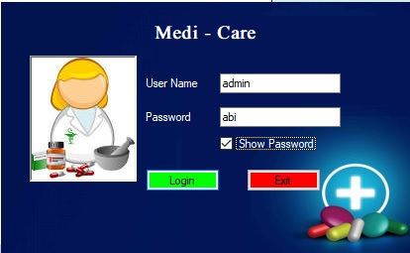

Home Page
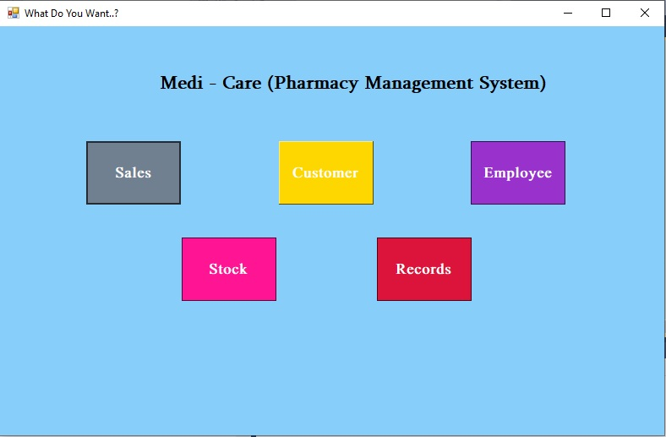

Customer Details

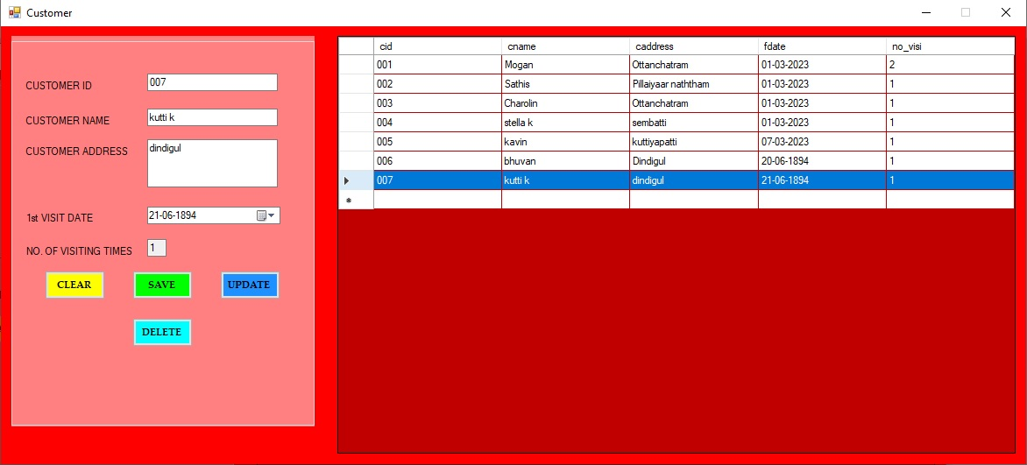

Employee Details

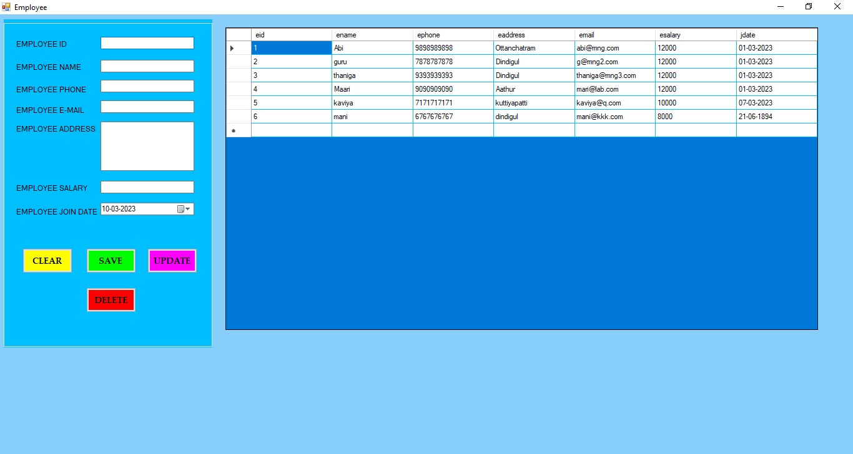

Stock Details
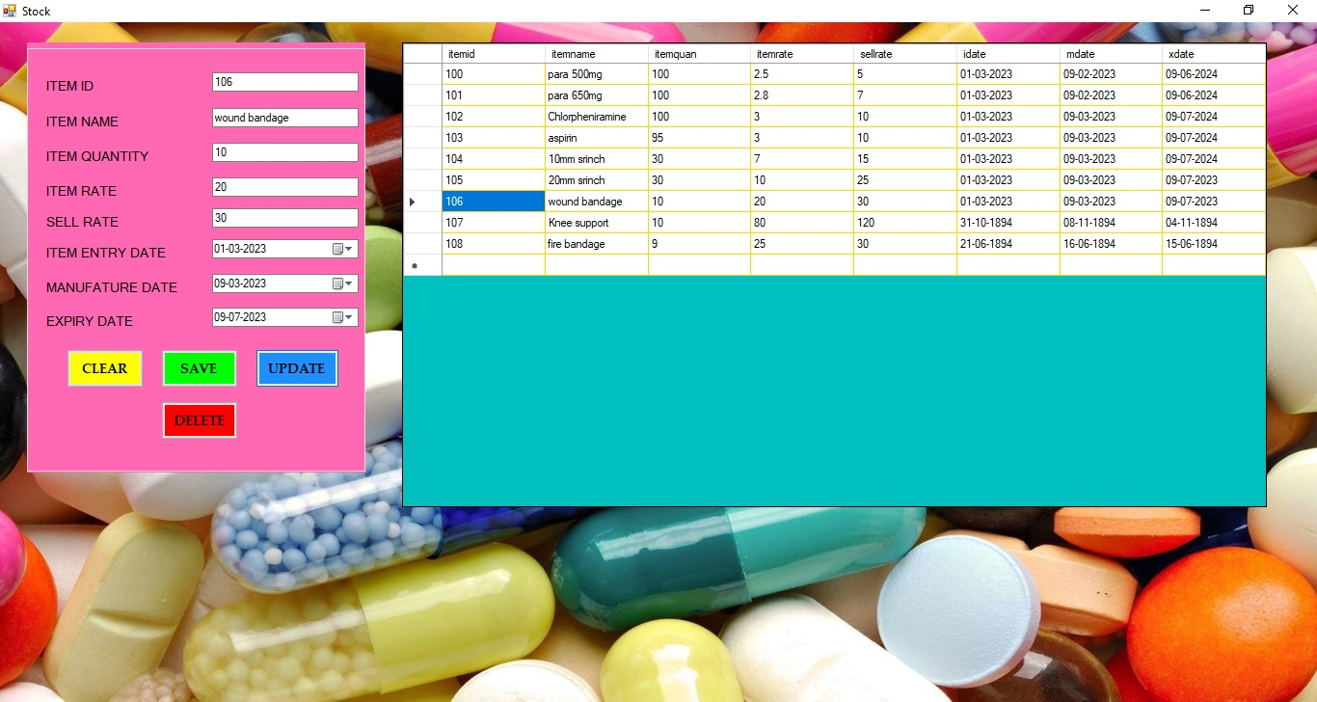

Info page

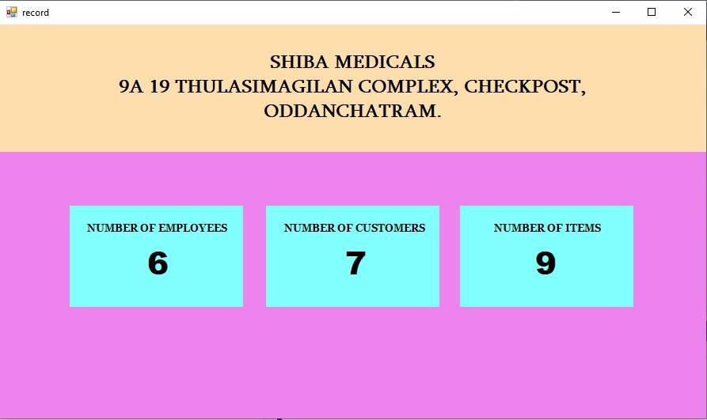

Sales Details

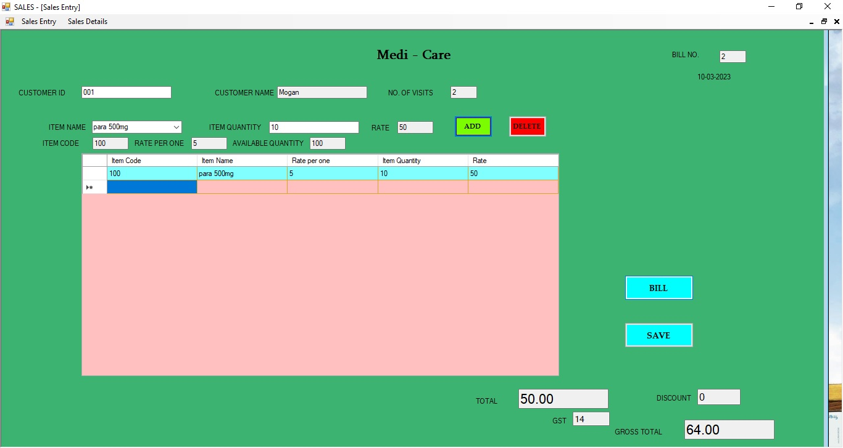

Sales Details Viewer

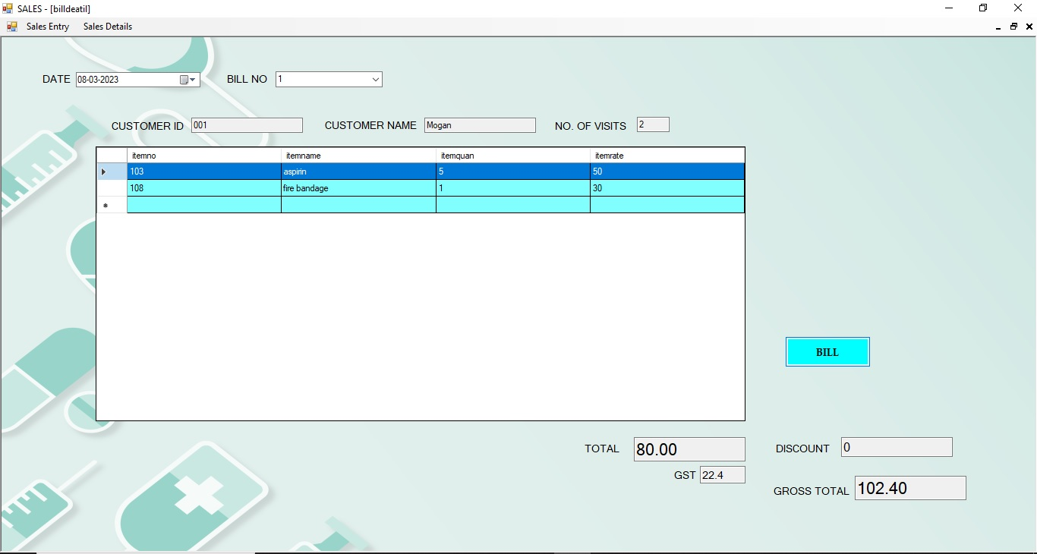

SAMPLE CODING

SAMPLE CODING
Coding for login

Code line for database connection:
Dim cn As New OleDbConnection("Provider=Microsoft.ACE.OLEDB.12.0;Data Source=E:\Workshop\VS\medicare\medicare.accdb")

Code for checkbox :
Private Sub CheckBox1_CheckedChanged(ByVal sender As System.Object, ByVal e As System.EventArgs) Handles CheckBox1.CheckedChanged
If CheckBox1.Checked = True Then
TextBox2.UseSystemPasswordChar = False
Else
TextBox2.UseSystemPasswordChar = True
End If
End Sub
Code for exit button :
Private Sub Button2_Click(ByVal sender As System.Object, ByVal e As System.EventArgs) Handles Button2.Click
Application.Exit()
End Sub
Code for login button :
Private Sub Button1_Click(ByVal sender As System.Object, ByVal e As System.EventArgs) Handles Button1.Click
If TextBox1.Text = "admin" And TextBox2.Text = "abi" Then
Form2.Show()

Me.Visible = False
Else
MsgBox("Check the details")
End If
End Sub
Code for delete button :
cn.Open()
Dim cmd1 As New OleDbCommand("delete from employee where eid ='" & TextBox1.Text & "'", cn)
cmd1.ExecuteNonQuery()
MsgBox("deleted")
cn.Close()

Code for save button :
cn.Open()
Dim cmd As New OleDbCommand("insert into employee(eid,ename,ephone,email,eaddress,esalary,jdate) values ('" & TextBox1.Text & "','" & TextBox2.Text & "','" & TextBox3.Text & "','" & TextBox4.Text & "','" & TextBox5.Text & "','" & TextBox6.Text & "'," & DateTimePicker1.Text & ")", cn)
cmd.ExecuteNonQuery()
MsgBox("added")
cn.Close()
Code for update button :
cn.Open()
Dim cmd4 As New OleDbCommand("update employee set ename='" & TextBox2.Text & "',ephone='" & TextBox3.Text & "',email='" & TextBox4.Text & "',eaddress='" & TextBox5.Text & "',esalary='" & TextBox6.Text & "',jdate='" & DateTimePicker1.Text & "' where eid='" & TextBox1.Text & "'", cn)
cmd4.ExecuteNonQuery()
MsgBox("Updated")
cn.Close()
Code for Datagrideview :
cn.Open()
Dim cmd2 As New OleDbCommand("select * from employee", cn)
cmd2.ExecuteNonQuery()
Dim da As New OleDbDataAdapter(cmd2)
Dim dt As New DataTable
da.Fill(dt)
DataGridView1.DataSource = dt
cn.Close()

